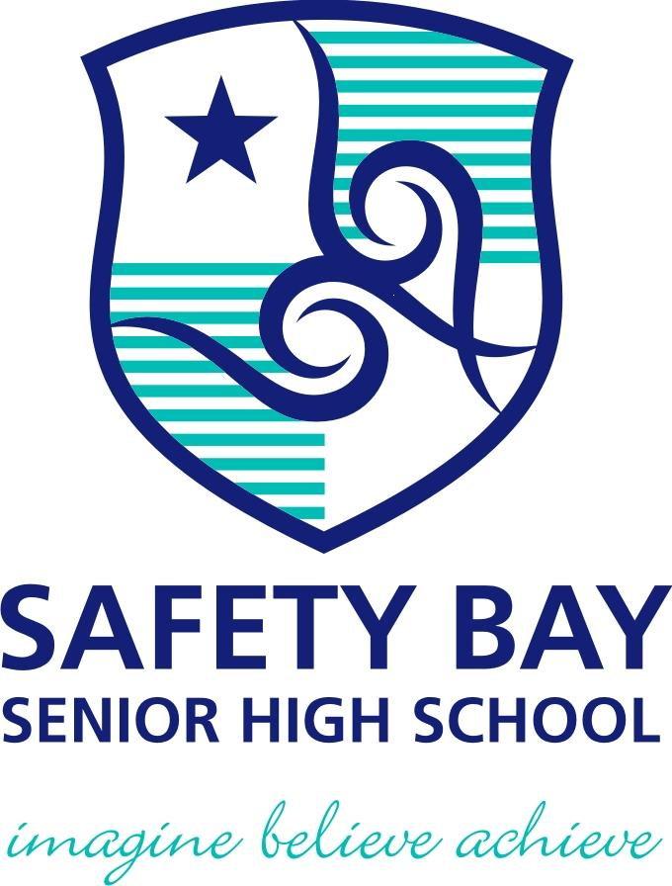

YEAR: 8
SUBJECT: SCIENCE

TEST: Physical and chemical change
TIME: 55 mins
QUESTIONS: Part A: Multiple Choice Questions (10 marks)
Part B: Short Answer Questions (26 marks)
Part C: (30 marks)
TOTAL MARKS: 36 marks

DO NOT WRITE ON OR MARK THIS PAPER
Part A: Multiple Choice Questions (1mark each)
Answer this section on the separate multiple – choice answer sheet

1. Which of the following is a chemical change?

- Sawdust is produced from wood being cut by a power saw.
- Water freezes to form ice.
- Fireworks explode in a colourful light display.
- Juice is obtained from an orange.
2. A permanent colour change may be an indication that a chemical reaction has taken
place. Identify which of the following is not an indication of a chemical reaction.

- sugar caramelising
- toast bread
- a glass breaking
- burning a match

3. The substances that you begin within a reaction is called as
- reactants.
- products.
- elements.
- compounds.

4. Which of the following would NOT be a physical change?

- freezing water to make ice cubes
- melting gold to make jewellery
- burning gasoline in a lawnmower
- boiling water for soup
5. The term corrosion means:

- coating iron with a material such as paint
- a chemical reaction where a metal reacts with oxygen
- a chemical reaction where oxygen is a product
- is coating iron with zinc metal

6. The Law of Conservation of Mass states that ‘During a chemical reaction, atoms are
neither created nor destroyed’. This law suggests that if a chemical reaction occurred
inside a closed container, the total mass of the container and its contents would:

- increase as more chemicals are produced by the reaction.
- decrease if the chemical reaction produces a gas.
- stay the same.
- increase or decrease depending on the type of chemical reaction.
7. Joe collected some snow and placed it in a beaker. During the day it melted to produce
clear water. Joe and his friends made the following comments about the process.

Joe: This is a chemical change as there is a change in colour.
Jill: The beaker is now warmer than when you collected the snow. This must be a
chemical change as energy is absorbed.
Jenny: This is a physical change as the trapped air bubbles react with the snow.
Jamal: This is a physical change as no new substances are created.
State who you believe is correct.

- Joe
- Jill
- Jenny
- Jamal

8. Analyse the word equation:
methane + oxygen → carbon dioxide + water + energy
This reaction shows that:

- oxygen is a product of this reaction.
- methane burns with a sooty flame.
- this is an exothermic reaction.
- a constant input of energy is required to keep the reaction going.

9. Identify which of the following would indicate an endothermic reaction.

- a gas is given off
- the reaction glows
- a precipitate forms
- the reaction feels cold to the touch

10. The recycling of aluminium can be considered a series of physical changes as shown
by the flow diagram below.

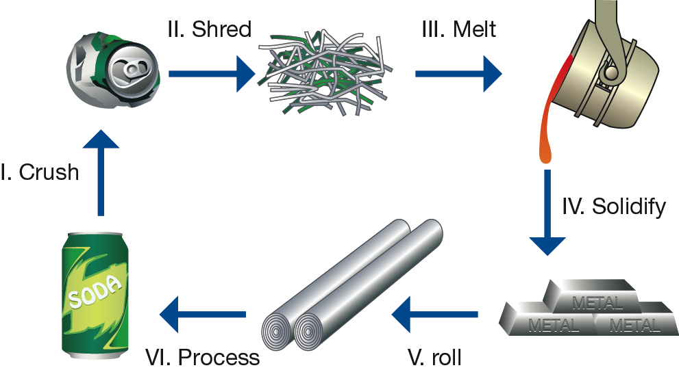

Which stages of the aluminium recycling process would be considered a change of state?

- I and II
- II and III
- III and IV
- only III

YEAR: 8
SUBJECT: SCIENCE
Name__________________________________________________
Form ____________

TEST: Physical and chemical change
TIME: 55 mins
QUESTIONS: Part A: Multiple Choice Questions (10 marks)
Part B: Short Answer Questions (26 marks)
Part C:

TOTAL MARKS: 32 marks

Part A: Multiple Choice Answers (1mark each)
Put a cross (X) through the correct answer.

1 a b c d
2 a b c d
3 a b c d
4 a b c d
5 a b c d
6 a b c d
7 a b c d
8 a b c d
9 a b c d
10 a b c d

Marks

Part A: Part B:
Multiple Choice Short Answer Total

/10
/20

/26

/36

Part C:

/30
Part B: Short Answer Questions
11. Define the term precipitation. (1mark)
______________________________________________________________________________________________________________________________________________________
12. Label each process as a physical or chemical change: (6 marks)
Slicing potatoes for fries
A nail rusting
Baking cookies
Butter melting
Food spoiling
You cut your hair

13. a) Write word equations for the following chemical reactions. (2 marks)
i) Hydrogen gas and oxygen gas combine to form water.
___________________________________________________________________________
ii) Heating copper carbonate forms copper oxide and carbon dioxide.
___________________________________________________________________________
b) Write the chemical equation for the following (2 marks)
i) Hydrogen gas and oxygen gas combine to form water.
___________________________________________________________________________
ii) Heating copper carbonate forms copper oxide and carbon dioxide.
___________________________________________________________________________

14. a) Explain the difference between the terms reactants and products. (2 marks)
__________________________________________________________________________
___________________________________________________________________________
___________________________________________________________________________
___________________________________________________________________________
___________________________________________________________________________
___________________________________________________________________________

b) When magnesium metal reacts with hydrochloric acid, hydrogen gas and magnesium
chloride are formed. Identify the products and reactants of this reaction. (2 marks)

Products: _____________________________________________________________
Reactants: ____________________________________________________________

15. Complete the table below by filling in answers for parts a) to h) (8 marks)
Name | Formula
Water | a)
b) | H₂
Hydrochloric acid | c)
d) | K
Carbon dioxide | e)
f) | Cl₂
Sodium chloride | g)
h) | SO₃

17. You mix two unknown chemicals together and you expect a chemical reaction to occur. List 3 things you would look out for to know that a chemical change has occurred (3 marks)
__________________________________________________________________________
___________________________________________________________________________
___________________________________________________________________________
___________________________________________________________________________
___________________________________________________________________________
PART C:
18. a) A physical change occurs when _____________________________________________
_______________________________________________________________________
b) A chemical change occurs when ____________________________________________
________________________________________________________________________
(2 marks)
19. (A) Identify each of the following as a Physical or Chemical change.
Put a P next to Physical Changes Put a C next to Chemical Changes
- A piece of wood burns to form ash __________________________
- Water evaporates into steam __________________________
- A piece of cork is cut in half __________________________
- A bicycle chain rusts __________________________
- Food is digested in the stomach __________________________
- A popsicle melts __________________________
- A tire inflated with air __________________________ (5 marks)

(B) Choose 2 of the above examples and explain why you choose chemical or physical.
Please choose one of each type of change.

Physical change explanation: _________________________________________
_____________________________________________________________________
_____________________________________________________________________
_____________________________________________________________________
_____________________________________________________________________
(2 marks)
Chemical change explanation: _____________________________________________
_____________________________________________________________________
_____________________________________________________________________
_____________________________________________________________________
_____________________________________________________________________
(2 marks)

3. Identify three signs that a chemical change has occurred.
_______________________________________________________________________
_______________________________________________________________________
______________________________________________________________________
_______________________________________________________________________
(3 marks)

4. Read each scenario. Decide whether a physical or chemical change has occurred and give evidence for your decision.
 | Scenario | Physical or Chemical Change? | Evidence….  1 piece – ½ mark  2 pieces – 1 mark
1 | Your friend decides to toast a piece of  bread, but leaves it in the toaster too long.  The bread is black and the kitchen is full of smoke.
2 | You blow to dry your wet hair.
3 | You forgot to dry the bread knife when you washed it and reddish brown spots appeared on it.
4 | A straight piece of wire is coiled to form a spring.
5 | In baking biscuits and other quick breads, the baking powder reacts to release carbon dioxide bubbles. The carbon dioxide bubbles cause the dough to rise.
6 | Food colour is dropped into water to give it colour.
7 | You take out your best silver spoons and notice that they are very dull and have some black spots.
8 | In a fireworks show, the fireworks explode giving off heat and light.

(16 marks)

